# MicroStrategy Installation Steps for Windows

Enter the below link in order to download the MicroStrategy Workstation file Link:

[Workstation (microstrategy.com)](https://www.microstrategy.com/en/get-started/workstation)

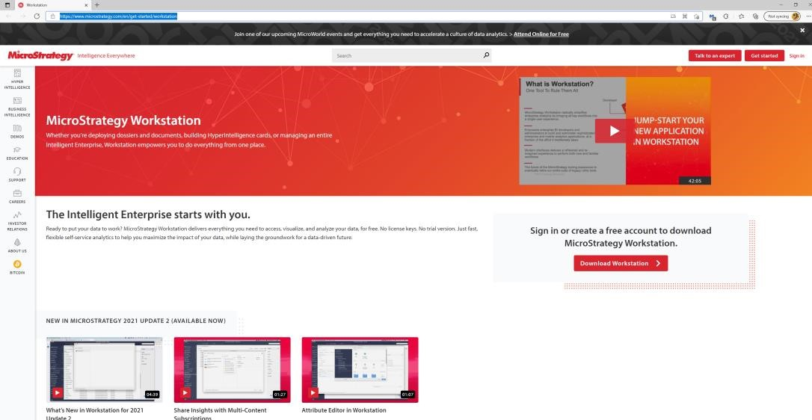

Then click on Download Workstation.

Once you click on Download now, you will be able to see a page which will ask for you to sign in or create an account. Click create an account and enter in your information.

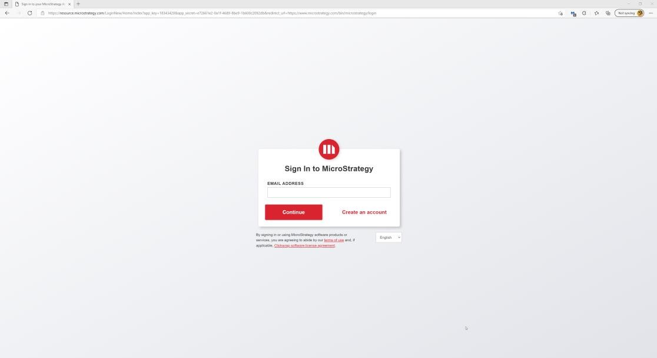

Please register with your college email-id and enter the information required in the boxes.

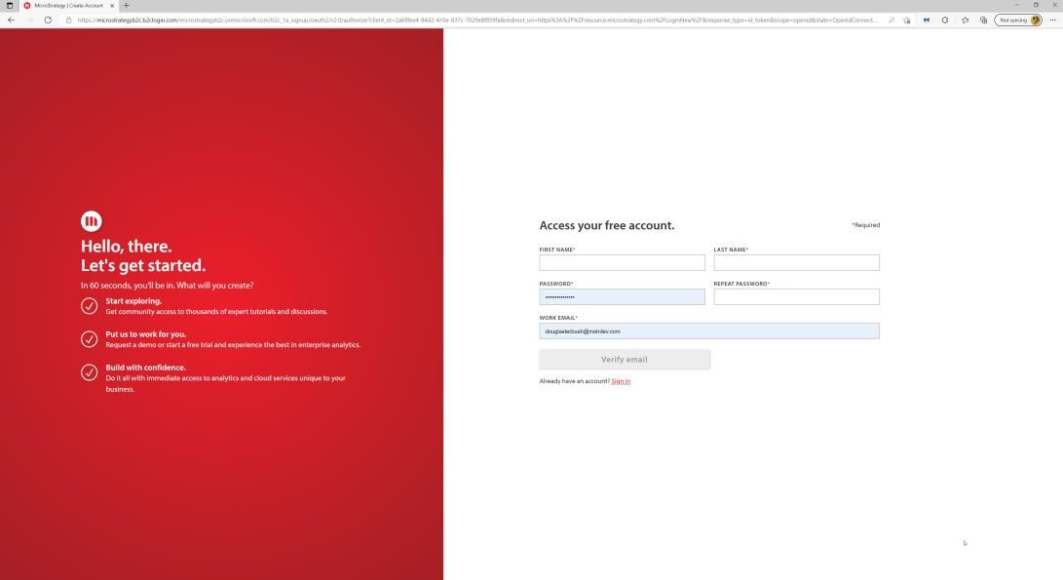

Once complete, you will be able to see the below page, then click on **Download Workstation.**

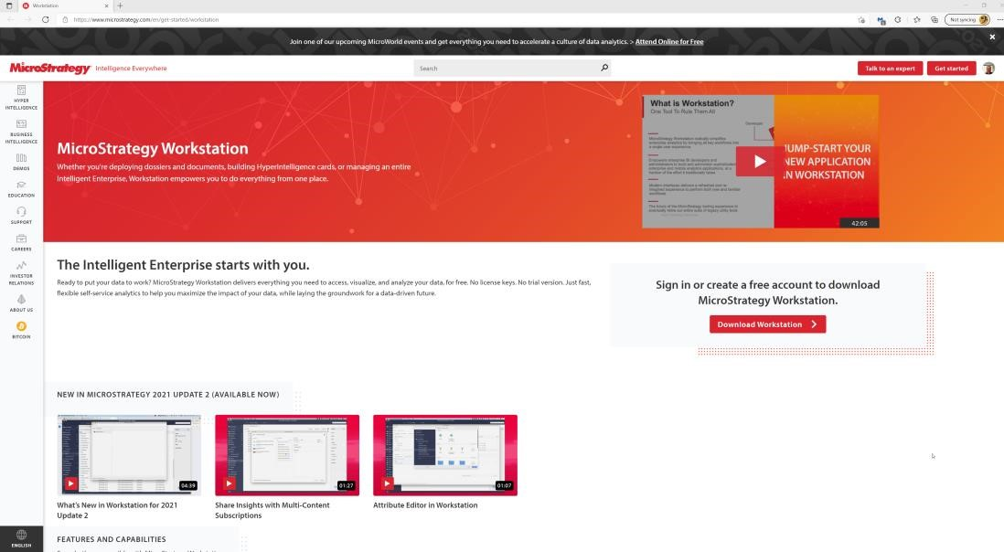

Once selected, a sub menu displays, then click on **Workstation for Windows** if you are a Windows user or **Workstation for Mac** if you are a Mac user.

Once the download of MicroStrategy installation file is complete, unzip the file, then double click on the **WorkstationSetup** file in order to start the installation. Below is the screenshot of the screen which will first pop-up once you click on the file.

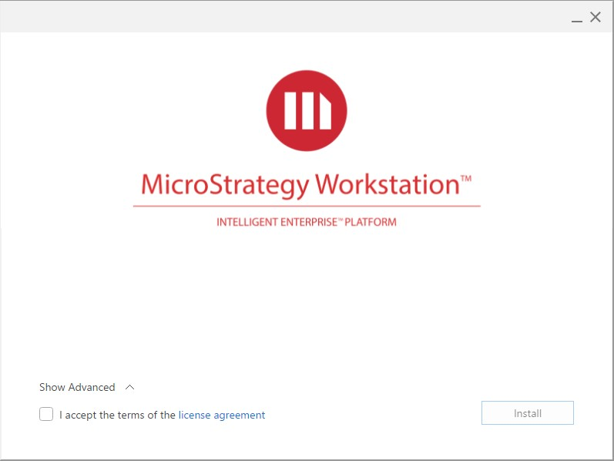

Click on the checkbox “I accept the terms of the license agreement” to agree with the license agreement.

Click on Install to proceed with the installation.

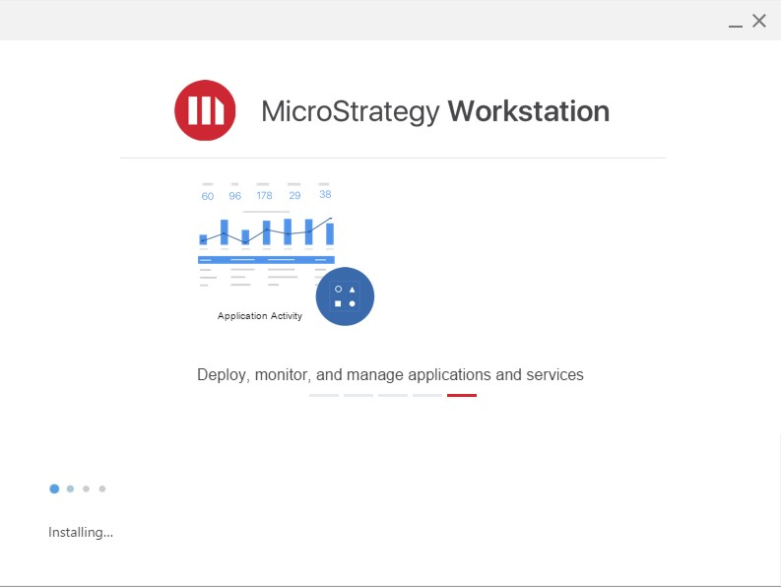

This will take 3-5 minutes in order to complete the installation.

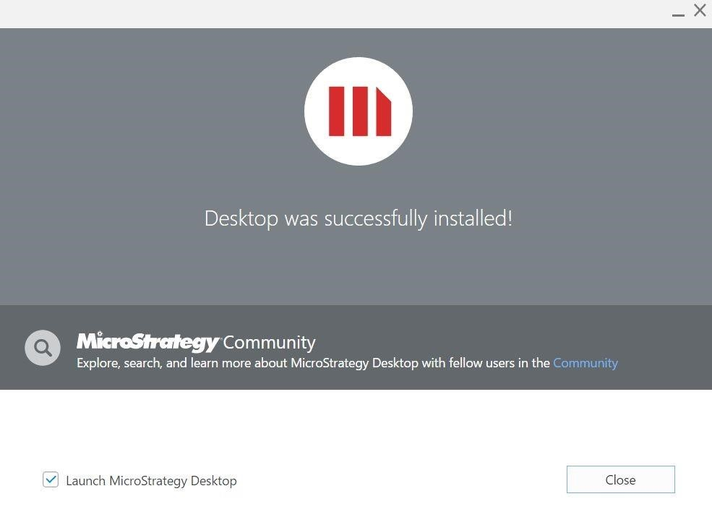

Click the checkbox “Launch MicroStrategy Workstation” and then click on Finish in order to complete the installation. The below screen shows you the version of the Microstrategy Workstation installed.

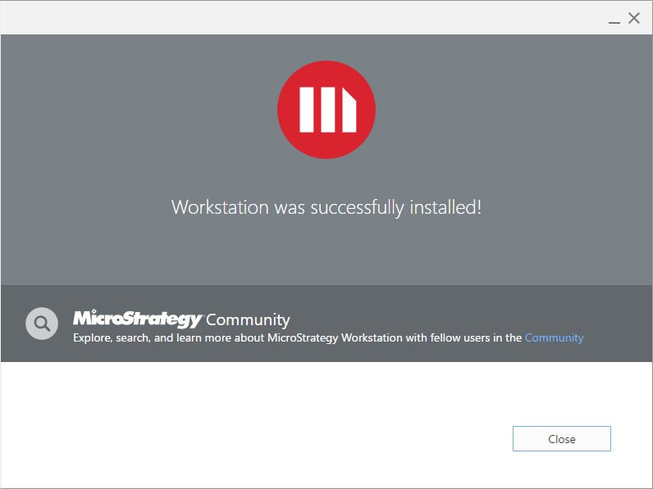

Once MicroStrategy is downloaded and installed. There will be a MicroStrategy icon on your desktop. Double click on the icon and open the application.

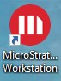

Once the MicroStrategy installation is complete, let’s jump to install the Oracle VM.